PHY 134.L69 Lab Syllabus

Welcome to the PHY 134 Lab! This lab class is a so-called “online lab”. It is perhaps better described by the phase “at home” laboratory. You will purchase the ioLab device as part of a lab kit and use these items to perform all your experiments. Following each experiment you will submit a lab report through Brightspace and take a quiz testing your understanding of the material for the lab.

ioLab Device
Macmillan publishing distributes the so-called ioLab device. Each student should purchase their own ioLab from Macmillan. The web page is somewhat confusing. You will need the KIT (not merely the device). The KIT is known as the “package” and the web site looks as follows:
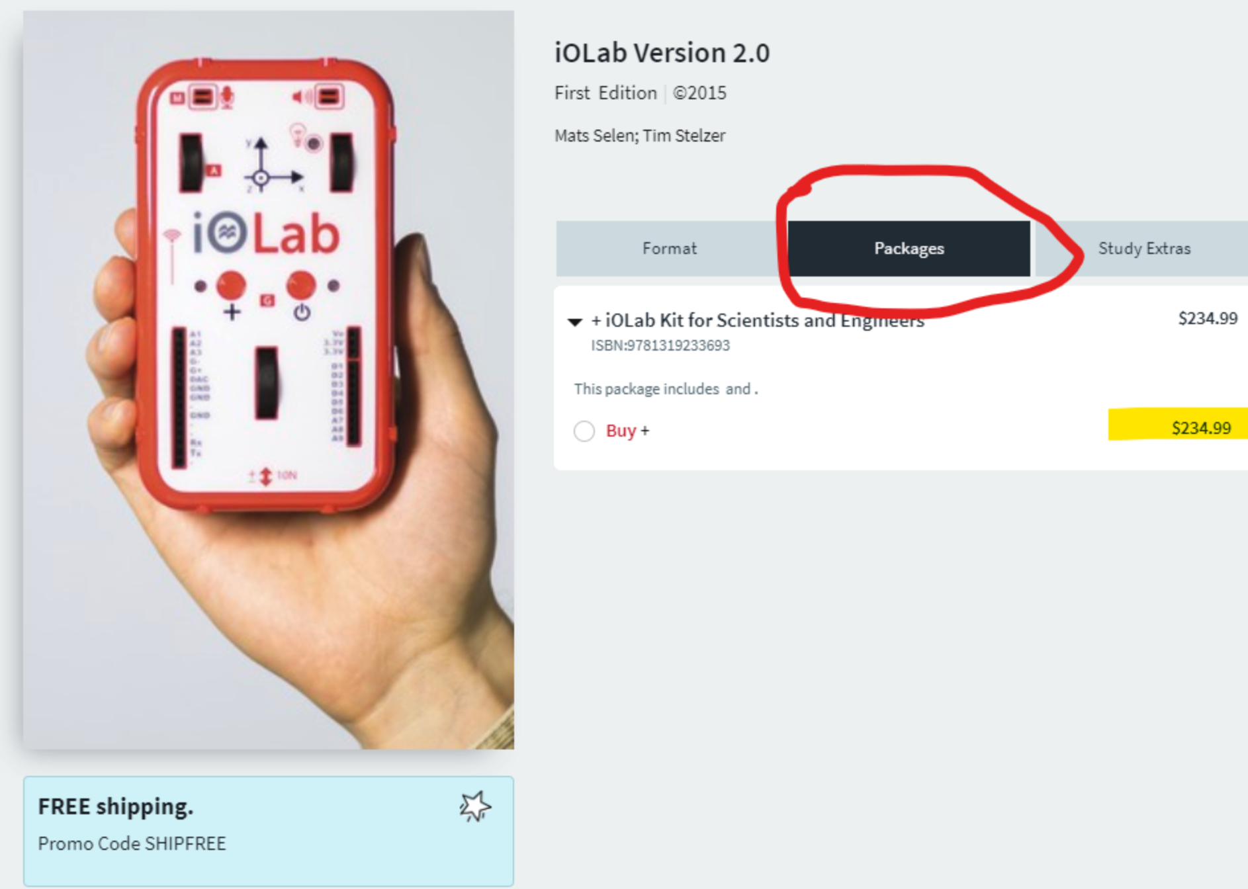
(Prices appearing in this screenshot may not be up to date.) This device will serve all your needs for PHY 133.L69 and PHY 134.L69.
After you receive the device, follow ALL the instructions found in the “Set up the ioLab” module in the Brightspace page for our class in order to get the device and the lab writeups properly installed. Be particularly careful about the folder into which you installed the lab manuals. If correctly done, you will be able to open the lab manuals inside the ioLab app. If incorrectly done, you will open them in a web browser and equations will not be shown.

Lab Reports
The expectations for lab report content are discussed in detail in Brightspace. A guiding principle of the lab writeup is to write a standalone document. You can be brief, but your document should be sufficient for someone else to:
- Understand what you wanted to prove
- Understand how what you decided to measure
- See what you did measure
- See what you calculated
- REPRODUCE YOUR CALCULATIONS (!!!)
- Understand what you concluded.
Your lab reports will be handed in through the “Turnitin” system. This system compares your report to all other students in your class, all other students from prior classes, and the internet. TAs will investigate cases of high plagiarism score. Both the student who copied and the student who was copied-from will receive zeroes on the lab report.

Lab Quizzes
In addition to the lab report, you must complete a lab quiz, meant to test you on what you did and what you have learned during the lab. Both are due on the same day, but it is suggested to do the lab quiz AFTER the lab report so that you can benefit from having learned something by performing the lab. The quizzes will be posted in Brightspace under the Exams/Quizzes tab. You must complete each lab quiz in one sitting, so make sure to set aside enough time for it.

Grade Determination
Your course score will be a weighted average of the reports (80%) and the quizzes (20%). To compensate for potential equipment malfunctions, your lowest quiz and lowest lab scores will be dropped from the calculation. Your course letter grade then will be set on the following scale:
 | A | A- | B+ | B | B- | C+ | C | C- | D+ | D | F
Percentage | > 90 | 85-89 | 80-84 | 75-79 | 70-74 | 65-69 | 60-64 | 55-59 | 50-54 | 45-49 | < 45

Labs
The list of labs includes:
- Orientation (not for credit)
- Electric Field
- Breadboard
- Ohm’s Law
- Kirchhoff’s Rules
- RC Circuits
- Magnetic Force
- Magnetic Field
- Faraday’s Law
- RLC Circuits
- Snell’s Law
- Diffraction

Getting Help
Each student is assigned “their TA”. These assignments will be announced via the class Brighspace page. When requesting help, please do the following:
- Write to your TA.
- When appropriate attach a photo of your setup.

Student Accessibility Support Center
If you have a physical, psychological, medical, or learning disability that may impact your course work, please contact the Student Accessibility Support Center, 128 ECC Building, (631) 632-6748, or at sasc@stonybrook.edu. They will determine with you what accommodations are necessary and appropriate. All information and documentation is confidential.

Academic Integrity
Each student must pursue his or her academic goals honestly and be personally accountable for all submitted work. Representing another person's work as your own is always wrong. Faculty is required to report any suspected instances of academic dishonesty to the Academic Judiciary. Faculty in the Health Sciences Center (School of Health Technology & Management, Nursing, Social Welfare, Dental Medicine) and School of Medicine are required to follow their school-specific procedures. For more comprehensive information on academic integrity, including categories of academic dishonesty please refer to the academic judiciary website at http://www.stonybrook.edu/commcms/academic_integrity/index.html

Critical Incident Management
Stony Brook University expects students to respect the rights, privileges, and property of other people. Faculty are required to report to the Office of University Community Standards any disruptive behavior that interrupts their ability to teach, compromises the safety of the learning environment, or inhibits students' ability to learn. Faculty in the HSC Schools and the School of Medicine are required to follow their school-specific procedures. Further information about most academic matters can be found in the Undergraduate Bulletin, the Undergraduate Class Schedule, and the Faculty-Employee Handbook.

