AST 248: The Search for Life in the Universe

Spring 2023

MW 2:40 - 4:00, Frey Hall 104
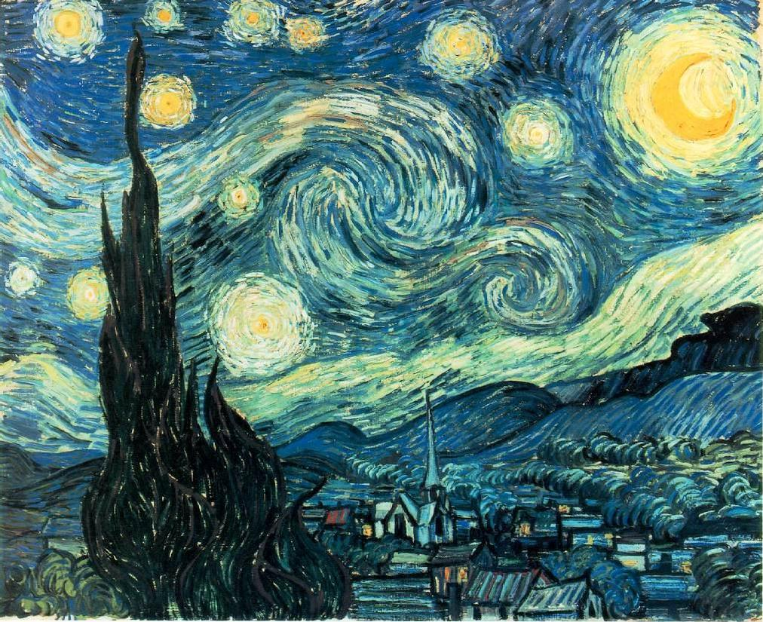
- Instructor: James Lattimer james.lattimer @ stonybrook.edu
    - Office: ESS 449, 632-8227
    - Hours: MW 1:00 - 2:00; F 2:30 - 3:30.
    - Additional assistance by appointment or Zoom.

• TA: TBD @ stonybrook.edu
  - Office:
  - Hours:
- Course URL is http://www.astro.sunysb.edu/lattimer/AST248/

Lectures are in-person, but will be live-streamed and accessible throughout the semester through ECHO360 in Blackboard. I will not respond to emails during the lecture; if you want to ask questions you must be in the classroom. During posted office hours, I will be in my office on Monday and Wednesday and and will initiate ZOOM meetings on Friday. You can also request an appointment for a different time if necessary. This webpage acts as the course syllabus, which you can print if you wish. It will be updated with announcements as necessary during the semester.

Lecture notes are posted here.

Grades and assignments are posted on Blackboard. The course may migrate to Brightspace during the semester.

- Required text:"Life in the Universe" 4th edition by Bennett and Shostak. You may use earlier editions, but the syllabus is keyed to pages in the fourth edition. I've also added a key to pages in the 3rd edition. The relevant pages differ in the first and second editions. You are also responsible for additional material found in the 4th edition.
- Supplementary (non-required) texts: "Here Be Dragons" by Koerner and LeVay, and "The Science of Aliens" by Pickover. "Here Be Dragons" is out of print, but used copies should be available online. These books were not ordered in the bookstore.

Considerable additional material will be presented in the lectures. Some, but not all this additional material, will be posted on this website in the class notes. In any case, you are responsible for all material presented in class, whether or not it is posted.
- Exams: There will be three major exams, each counting 20% of the final grade. Exams on February 22 and April 5 will be in the classroom during the scheduled class time; the third exam will be in the classroom at the time reserved for final exams by the Provost, Wednesday, May 17, beginning 11:15AM and lasting 80 minutes. Each exam is non-cumulative and primarily covers material from lectures and homeworks prior to the exam. The exam format is multiple choice and true/false marked on a scantron sheet which I will provide. You need to bring #2 pencils and erasers. No additional aids are allowed, including calculators, phones, iPads, books or notes.

Grade Correspondence for the Major Exams
EXAM | A | A- | B+ | B | B- | C+ | C | C- | D+ | D | F
# 1 | - 100 | - | - | - | - | - | - | - | - | - | 0 -
# 2 | - 100 | - | - | - | - | - | - | - | - | - | 0 -
# 3 | - 100 | - | - | - | - | - | - | - | - | - | 0 -

- Make-up exams require a valid, documented excuse (doctor's/infirmary note, obituary notice, police accident report, etc.).
- Homeworks: Homeworks will be posted on Blackboard one week before they are due. Completed homeworks must be submitted to Blackboard by the due dates (midnight Friday nights) to be fully counted. Late homeworks will be accepted up to one week after the due date, but they will be downgraded by at least 50%. There will be 11 homework assignments except for the first week and the two weeks with in-class exam. We prefer homeworks to be submitted as pdf attachments to Blackboard. Word documents are sometimes not easily read on Blackboard. Supplementary algebra or math for the homeworks may be scanned and submitted as jpg or gif files if they contain legible handwriting. These policies are not inflexible, and lengthy absences for athletic, health or other documentable reasons will be accommodated.

The total of your 9 highest homeworks will count for 20% of your final grade. The lowest two homework grades will be dropped, but a small credit is given if all 11 homeworks are submitted.
- Term Reports: One term report will count 20% of the final grade. The due date for this report is midnight on Friday, 24 March, and must be submitted, preferably as a pdf file, to Blackboard. Papers submitted between 25 March and 31 March will be assessed the equivalent of 1/2 letter grade penalty, those submitted between 1 April and 7 April have 1 letter grade penalty, those submitted between 8 April and 14 April have 1 1/2 letter grades penalty, those submitted between 15 April and 21 April have 2 letter grades penalty. The first paper will not be accepted after April 21. You should check Blackboard for the status and grade of your paper.

The length should be approximately 8 - 12 double-spaced typed pages. Make sure your document is readable as a pdf file. Some suggested topics are listed below, but you can write about any course-theme related topic from a scientific perspective. The key course themes are the origins of life, the evolution of life/intelligence, and the searches for life. You should find at least three, and preferably more, recent (i.e., within the last 3 years) sources on which to base your report. Books, magazines or newspaper articles are acceptable, as are internet web pages if you identify your sources and conclude they are providing reliable information. (For example, NASA or ESO web pages are suitable. Wikipedia may be used in a supplementary fashion only. TV documentaries and blogs are not acceptable sources of information. Unacceptable sources are articles from the Daily Mail, Buzzfeed, Fox, Natural or Breibart News. Any publication with a fringe topic (i.e., creationism, alternative medicine, conspiracy theories, etc.) should be treated with caution. Your report should not use the lecture notes or the required text as primary references, and neither should it use matter copied directly. Your paper must go into more depth and detail than the textbook or the class notes on your specific topic. Footnotes and detailed referencing are not required, but your paper must include a bibliography containing the sources from which material was taken. If you use a figure or table, you must cite the source at the place where the figure or table appears. Your paper will be graded on its relevance to our course, its originality (i.e., its synthesis of different sources and contrasting or competing ideas), its detail, and the quality of the research you performed in its writing.

Some Possible Topics for Term Papers (add "and Their Relevance to our Course" to each):

Topic
1 | Recent Discoveries Concerning Extrasolar (and Possible Earth-Like) Planets
2 | The Fermi Paradox and Its Resolution
3 | Recent Discoveries Concerning Extremophiles
4 | Recent Discoveries Concerning Terrestrial Mass Extinctions (don't describe all of them, focus on discoveries relevant to one or two.
5 | How Important is Global Warming and is There Any Practical Mitigation Strateg?
6 | Recent Discoveries Concerning Kuiper-Belt Objects, Asteroids or Comets
7 | Can Interstellar Travel Be Made Practical Considering Realistic Physical and Financial Limits?
8 | Recent Discoveries About the Possibility of Life on Mars, Europa or Titan (don't write about all 3)
9 | Recent Discoveries Concerning the Evolution of the Brain
10 | Recent Discoveries Conerning the Earliest Appearance of Life on the Earth
11 | Recent Discoveries Concerning the Origin of Humanoids
12 | What Does the COVID Pandemic Say About Mankind's Likely Response to Existential Threats, Such as Meteorite Impacts, Solar Flares or Climate Change?
13 | Ice Cores and What They Tell Us About the History of the Earth and Life
14 | Asteroid and Comet Impacts: What is the Risk and What Should We Do?
15 | Oxygenation of the Earth's Atmosphere and/or Snowball Earth Episodes and Their Roles in Evolution
16 | What Role Do Supernovae or Mergers of Neutron Stars Play in the Extinction of Life?
17 | What Threat Do Solar Flares Pose To Civilization and Life on Earth?
- Extra Credit: A second term report may be written for extra credit. The topic can be any topic you haven't already written about for the first paper. This paper should follow the same guidelines and submission procedure as the first term report. The optional report can be submitted after your first report is submitted but will not be accepted beyond April 28. The amount of extra credit will be determined by the grade you receive: An A will raise any exam or term paper grade (whichever gives the maximum increase in your overall course grade) by 2 letter grades. A B will raise any exam or term paper grade by 1 letter grade, and so on. For example, an A- on the extra-credit report could raise an exam grade from a C to an A-; an B- on the extra-credit report could raise an exam grade from a C to a B-; a C or lower grade will not raise a grade at all, but will not penalize you either unless plagiarism applies.

Plagiarism - Copying from currently or previously submitted papers or homeworks, copying directly from the WWW without attribution, or copying part of an article or book without reference will result in an "F" for the report or homework and a complaint will be filed with the student judiciary. Since I cannot determine who copied from who in the case of plagiarism of another student's work, both students will suffer the penalty. The tools on Blackboard allow you to see how much of your report has been copied from an internet source.
- Hints on how to succeed: 1, 2.
- Overall Grade: Exams, the term paper and the cumulative homeworks will count 20% each. The only opportunity for extra credit is the extra-credit term report.
- The threshold scores for letter grades are as follows: A 95-100; A- 90-94; B+ 87-89; B 83-86; B- 80-82; C+ 77-79; C 73-76; C- 70-72; D+ 65-69; D 60-64; F < 60. These letter grades are threshold scores only. Actual final scores needed to earn a certain letter grade may be lowered if warranted based on the difficulty of exams and homeworks. In other words if your score is 95% you would earn not less than an A, but I may set the threshold for an A to a lower score when all exams, homeworks and papers have been graded.

ACADEMIC INTEGRITY: Each student must pursue his or her academic goals honestly and be personally accountable for all submitted work. Representing another person's work as your own is always wrong. Any suspected instance of academic dishonesty will be reported to the Academic Judiciary. For more comprehensive information on academic integrity, including categories of academic dishonesty, please refer to the academic judiciary website.

ELECTRONIC COMMUNICATION: Email to your University email account is an important way of communicating with you for this course. For most students the email address is 'firstname.lastname@stonybrook.edu'. It is your responsibility to read your email received at this account, which is the only account to which you will receive communications about this course.

For instructions about how to verify your University email address see this. You can set up email forwarding using instructions here. If you choose to forward your University email to another account, we are not responsible for any undeliverable messages.

RELIGIOUS OBSERVANCES: See the policy statement regarding religious holidays. Students are expected to notify the course professors by email of their intention to take time out for religious observance. This should be done as soon as possible but definitely before the end of the 'add/drop' period. They are expected to discuss with the instructor(s) how they will be able to make up the work covered. Students must submit homeworks and term papers by the due date and late penalties will apply. Late penalties can be avoided by submitting papers and assignments in advance or by obtaining advance permission from the instructor.

DISABILITIES: If you have a physical, psychiatric/emotional, medical or learning disability that may impact on your ability to carry out assigned course work, you should contact the staff in the Student Accessibility Support Center (SASC), 632-6748. SASC will review your concerns and determine, with you, what accommodations are necessary and appropriate. All information and documentation of disability is confidential. I am not responsible for delivering an exam to the SASC office unless I am notified by YOU at least one day BEFORE the exam is scheduled. Do not assume the SASC office will be competent in informing me: you must do so yourself.

Students who require assistance during emergency evacuation are encouraged to discuss their needs with their professors and Student Accessibility Support Center. For procedures and information go to this website.

CRITICAL INCIDENT MANAGEMENT: Stony Brook University expects students to respect the rights, privileges, and property of other people. Faculty are required to report to the University Police and the Office of University Community Standards any serious disruptive behavior that interrupts teaching, compromises the safety of the learning environment, and/or inhibits students' ability to learn. See more here.

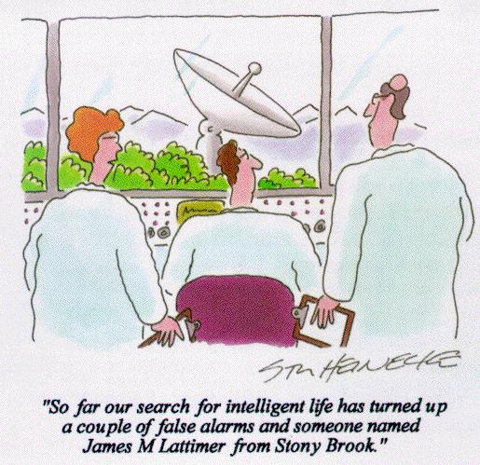

LECTURE TOPICS (SYLLABUS) USING 3RD EDITION

LECTURE TOPICS (SYLLABUS) USING 4TH EDITION

LECTURE NOTES

Red = no class; Black = an exam

Red superscript = homework # due
Sun | Mon | Tue | Wed | Thu | Fri | Sat
January
22 | 23 | 24 | 25 | 26 | 27 | 28
February
29 | 30 | 31 | 1 | 2 | 3¹ | 4
5 | 6 | 7 | 8 | 9 | 10² | 11
12 | 13 | 14 | 15 | 16 | 17³ | 18
19 | 20 | 21 | 22 | 23 | 24 | 25
March
26 | 27 | 28 | 1 | 2 | 3⁴ | 4
5 | 6 | 7 | 8 | 9 | 10⁵ | 11
12 | 13 | 14 | 15 | 16 | 17 | 18
19 | 20 | 21 | 22 | 23 | 24⁶ | 25
26 | 27 | 28 | 29 | 30 | 31⁷ | 1
April
2 | 3 | 4 | 5 | 6 | 7 | 8
9 | 10 | 11 | 12 | 13 | 14⁸ | 15
16 | 17 | 18 | 19 | 20 | 21⁹ | 22
23 | 24 | 25 | 26 | 27 | 28¹⁰ | 29
May
30 | 1 | 2 | 3 | 4 | 5¹¹ | 6
7 | 8 | 9 | 10 | 11 | 12 | 13
14 | 15 | 16 | 17 | 18 | 19 | 20

